Review on Angles

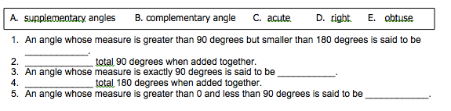
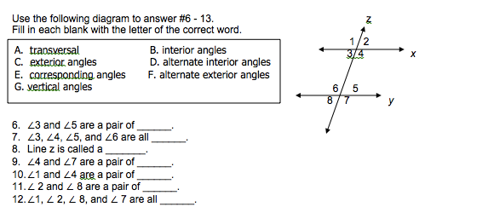

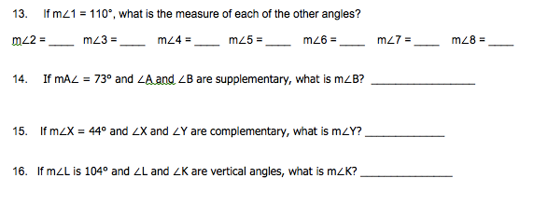
________________________________________________________________________
Find the measures of the numbered angles.
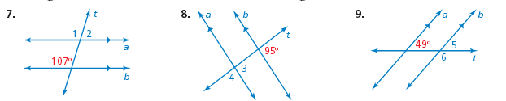

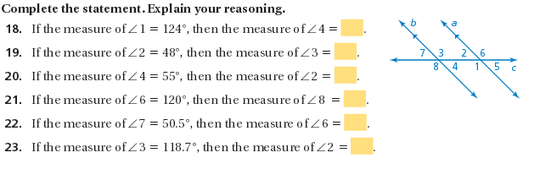
10.

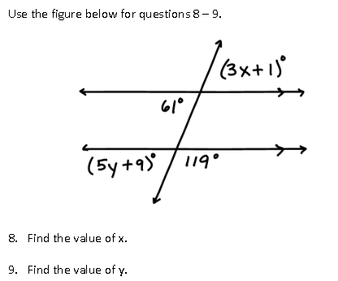
11-12

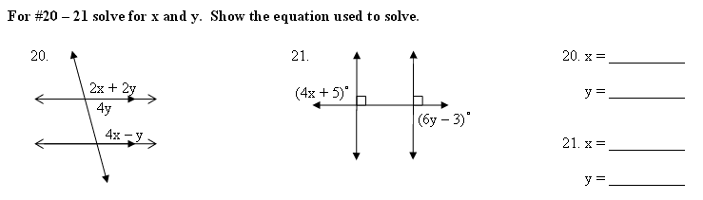
13.

Point B is between A and C. Solve for x.

14) AC = 3x + 3 , AB = -1 + 2x, and BC = 11 Find x.
Find x in the problem below.
15.

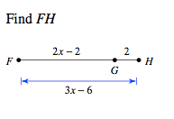
16.

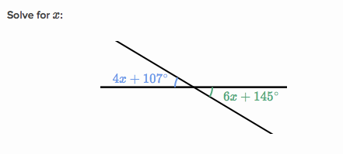

17. If one angle is represented by the expression (4x-7), and it's supplement is
is represented by the expression (9x+18), find the measure
of these angles.

18. Find x, y, z from the pair of complementary angles.

