Math 3
Congruent Triangle Proofs
Homework
________________________________
Name
Fill in the reasons.
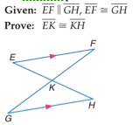
- Statements Reasons
1. EF $∥$ GH, EF $≅$ GH 1.
2. $∠$FEK $≅$ $∠$GHK 2.
3. $∠$EKF $≅$ $∠HKG$ 3.
4. $∆$ EFK $≅$ $∆$HGK 4.
5. EK $≅$ HK 5.

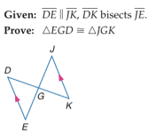
2. Statements Reasons
1. DE $∥$ JK, DK bisects JE 1.
2. $∠KJG$ $≅$ $∠DEG$ 2.
3. EG $≅$ JG 3.
4. $∠DGE$ $≅$ $∠KGJ$ 4.
5. $∆$EGD $≅$ $∆$JGK 5.

3. Statements Reasons
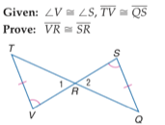
1. $∠$V $≅$ $∠$S, TV $≅$ QS 1.
2. $∠$1 $≅∠$2 2.
3. $∆$VRT $≅$ $∆$SRQ 3.
4. VR $≅$ SR 4.

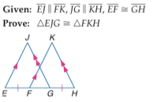
4. Statements Reasons 1. EJ $∥$ FK, JG $∥$ KH, 1.
EF $≅$ GH
2. $∠$JEG $≅$ $∠$KHF 2.
$∠$JGE $≅$ $∠$KHF
3. FG $≅$ FG 3.
4. EF = GH, FG = FG 4.
5. EF+FG=EG 5.
FG+GH=FH
6. FG+EF=FH 6.
7. EG=FH 7.
8. EG $≅$ FH 8.
9. $∆$EJG $≅$ $∆$FKH 9.

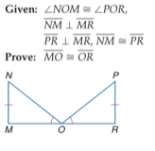
5. Statements Reasons 1. $∠$NOM $≅$ $∠$POR 1.
NM $⊥$ MR, PR $⊥$ MR
NM $≅$ PR
2. $∠$NMO and $∠$PRO are rt angles 2.
3. $∠$ NMO $≅$ $∠$PRO 3.
4. $∆$MNO $≅$ $∆$RPO 4.
5. MO$≅$ OR 5.

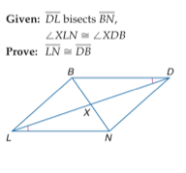
6. Statements Reasons
1. DL bisects BN 1.
$∠$XLN $≅$ $∠$XDB
2. BX $≅$ NX 2.
3. $∠$BXD $≅$ $∠$NXL 3.
4. $∆$LXN $≅$ $∆$DXB 4.
5. LN $≅$ DB 5.

