Review Unit 2
_____________________________
Name
Date: ___________ Pd: ____
Congruent Triangles

Determine if the following triangles are congruent. If congruent, state the postulate that allows you to prove congruency and write the congruency statement.
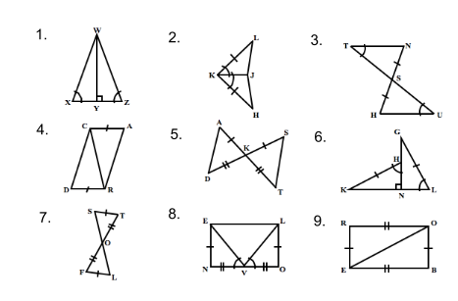
Given that ΔHIT ≅ ΔTOP, write an equation and solve for x in each of the following.
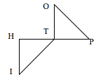
10. HT = 2x + 10, TP = 4x + 6, TO = 6x − 6 11. IT = 4x + 20, OT = 6x, IH = 2x + 44

Solve.
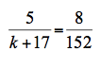
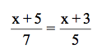
12. 13.

Similar Triangles

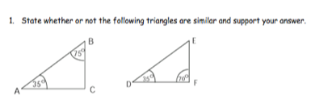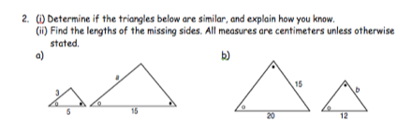

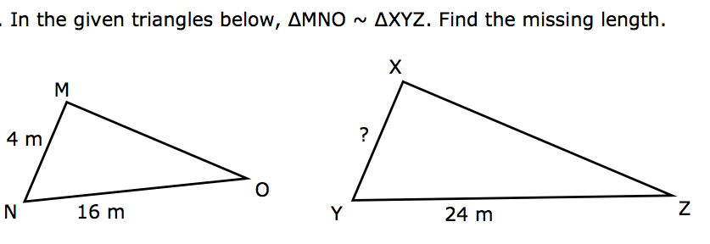
3. Are these triangles similar? 4.

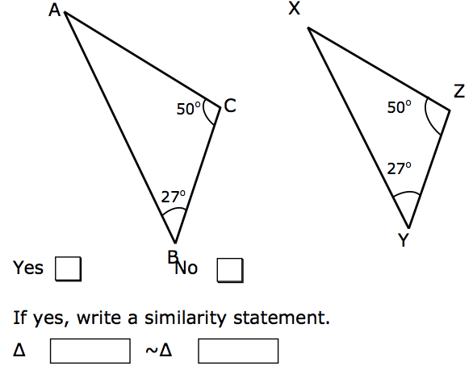

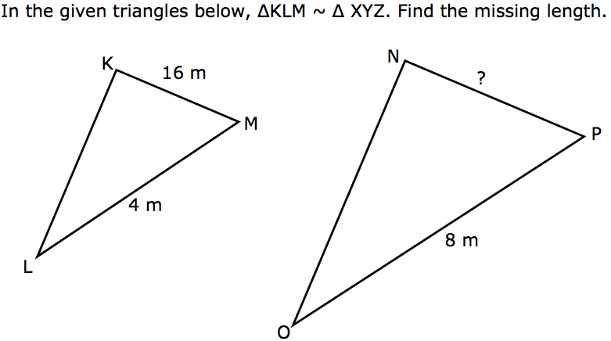
5.

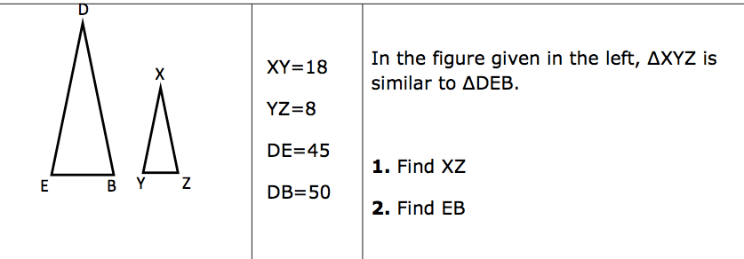
6.

.

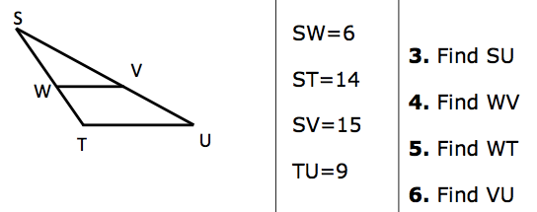
7.

8.

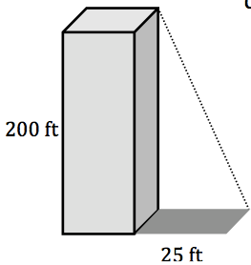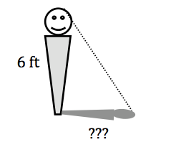

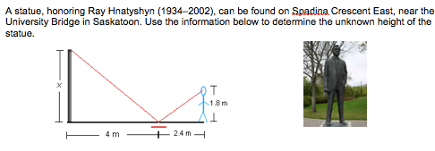
9.

Determine if the quadrilaterals below are similar. ( yes/no) Show proof.
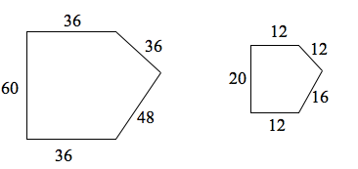
10.

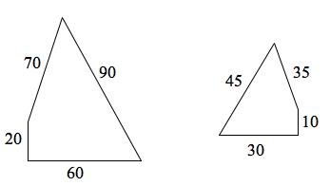
11.

Given the following parallelograms, find x.
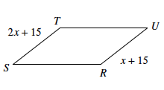
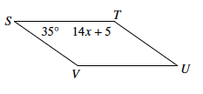
12. 13.

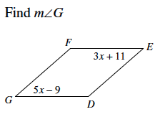
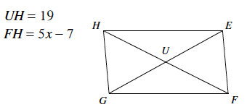
14. 15.

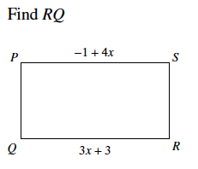
16.

